Instructions for completing an individual plan
Dear postgraduate students! You have been approved thesis title and supervisors. Now you have to fill out your individual plans for postgraduate students and approve it by your supervisors. This must be fulfilled on time strictly until the 25th of December.
We highly recommend you check carefully the assigned thesis and supervisor!!!

1) In the personal account of the ISU, select the section "Education and Science" (Образование и наука) -> "Individual Plans" (Индивидуальные планы):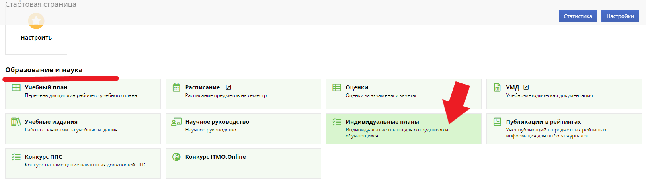

2) Next, click "Create Plan" (Создать план):
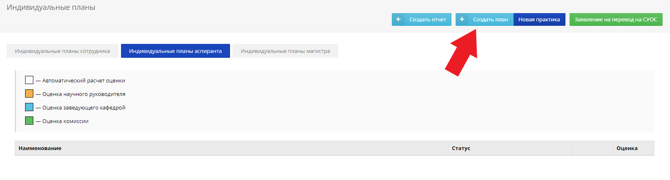

3) Then fill in ALL lines in accordance with the information to fill out an individual plan for your faculty:

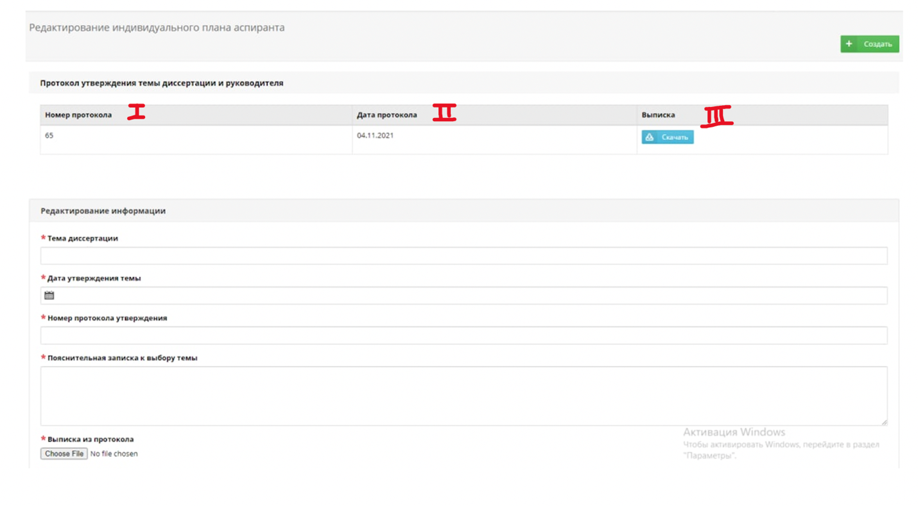

p.1 Thesis title (Тема диссертации): Carefully check the title of the topic of your dissertation !!!
p.2 Date (Дата утверждения темы) and p.3 Number of the protocol of approval the thesis (Номер протокола утверждения): The date and the number of the protocol of approval your thesis may be found in the extract from the protocol, you can find the document at the top of the page (table I – number of the protocol, table II – date, table III- the protocol).
p. 4 Explanatory note for the subject of the thesis (Пояснительная записка к выбору темы): the explanatory note should contain a brief description /summary/ abstract of the theoretical and experimental parts of your dissertation (at least 500 characters).
p.5 Extract from the protocol (Выписка из протокола): you need to attach an extract (scan-copy) from the protocol for your faculty (download the file from table III at the top of the page).
p.6 Foreign language (Иностранный язык): select the appropriate one. (For foreign postgraduates you need to choose Russian)

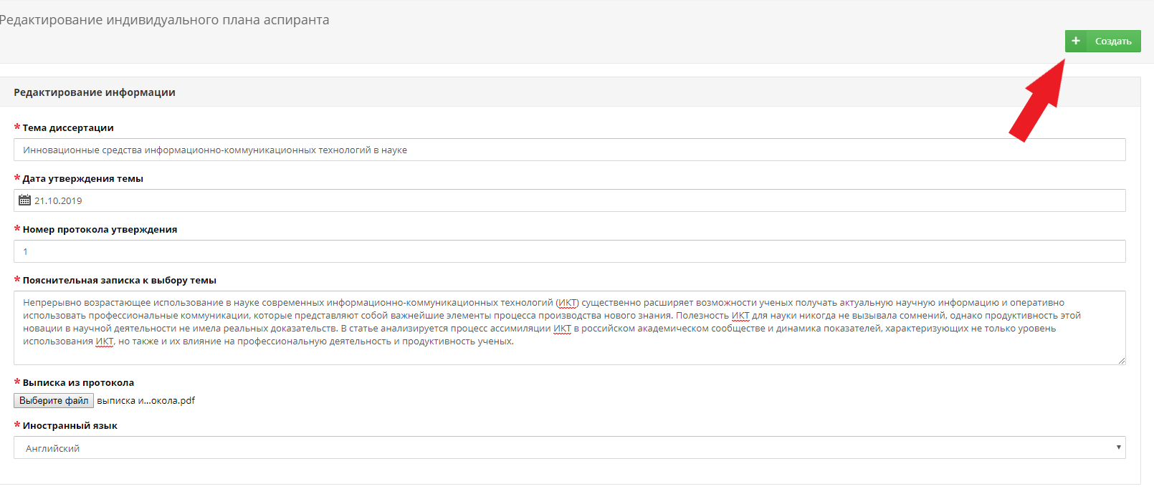
4) Click «Create» (Создать):

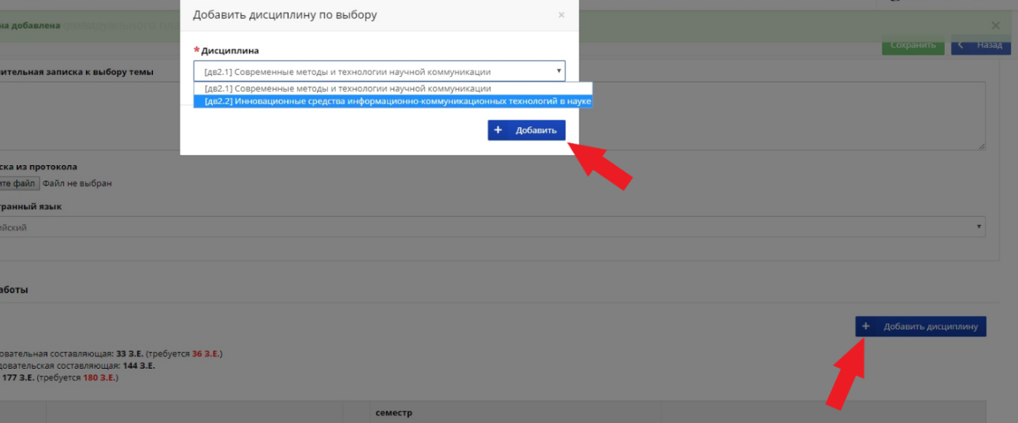
5) Next, you need to add (Добавить) 2 disciplines on your choice (the first one is by your choice, the second one is a foreign language (choose Russian if you are a foreign postgraduate student)):
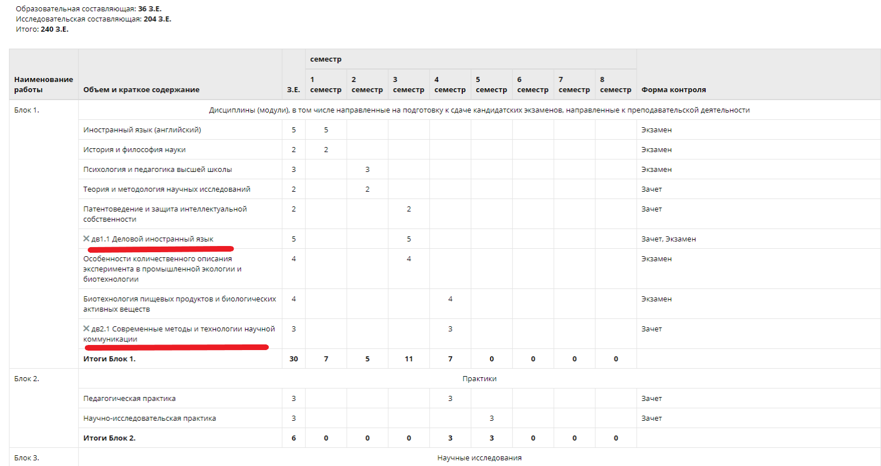

6) Затем нужно заполнить показатели по научно-исследовательской деятельности (подробнее можно узнать, нажав на знак вопроса):

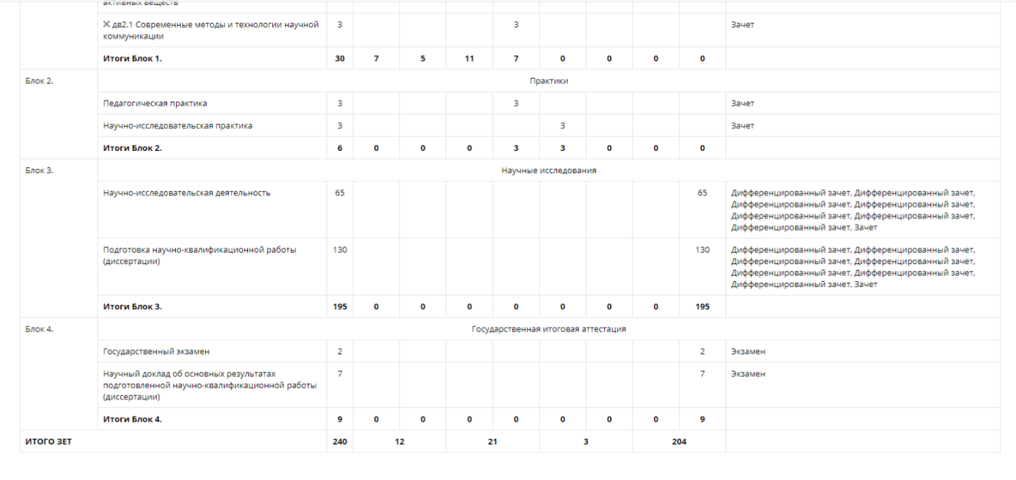
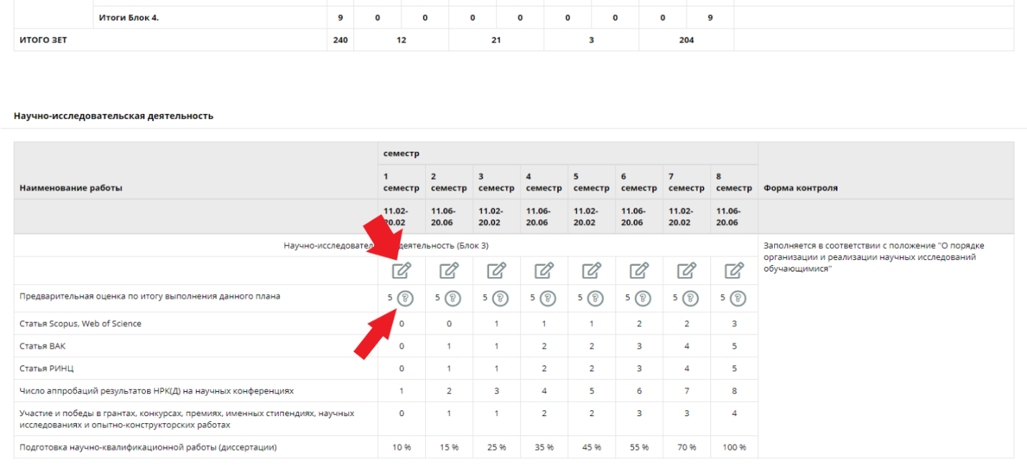
- Then you need to fill out the indicators for research activities (read more by clicking on the «?» mark):

7) After you have entered the indicators, click "Save" (Создать):

8) Now you need to send your individual plan for approval to your supervisor (Отправить на утверждение):

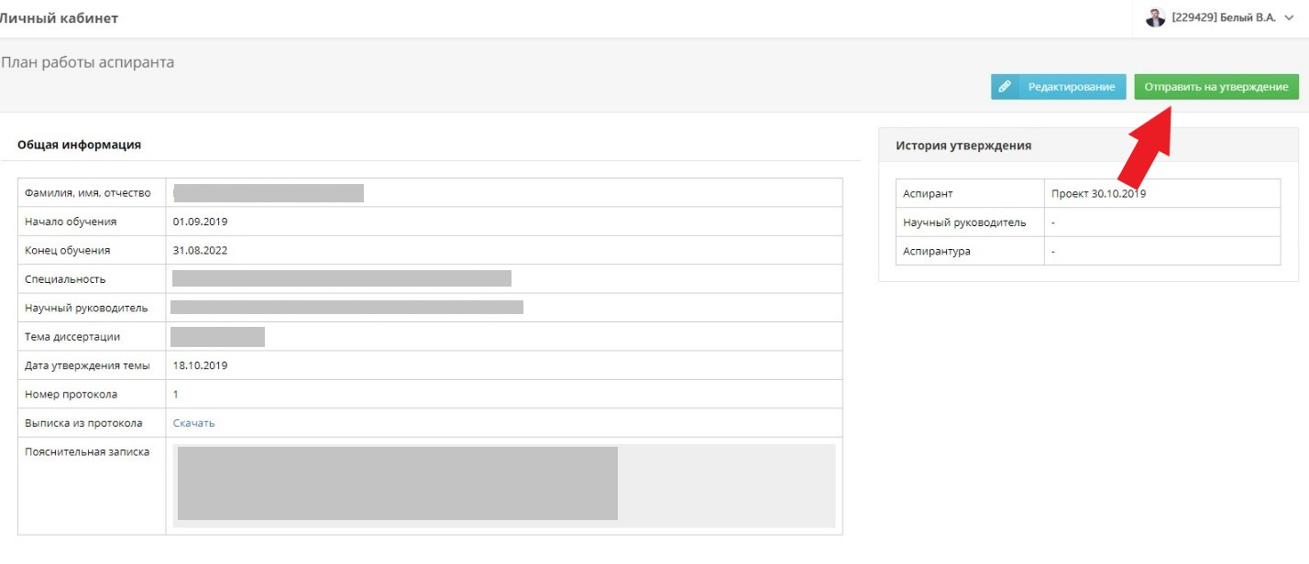

and wait for approval:

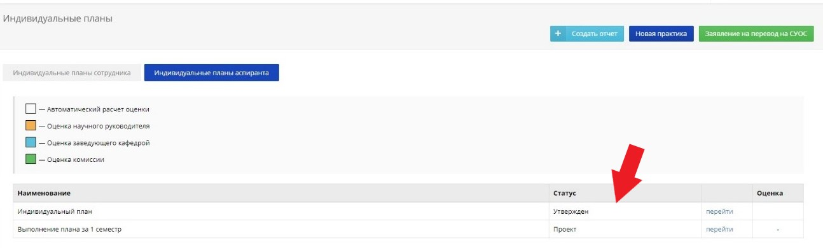

9) After your supervisor and the Department of International Postgraduate Studies have approved your individual postgraduate plan, you can start creating the report (Создать отчет). Don’t forget to remind your supervisor to approve your individual plan.
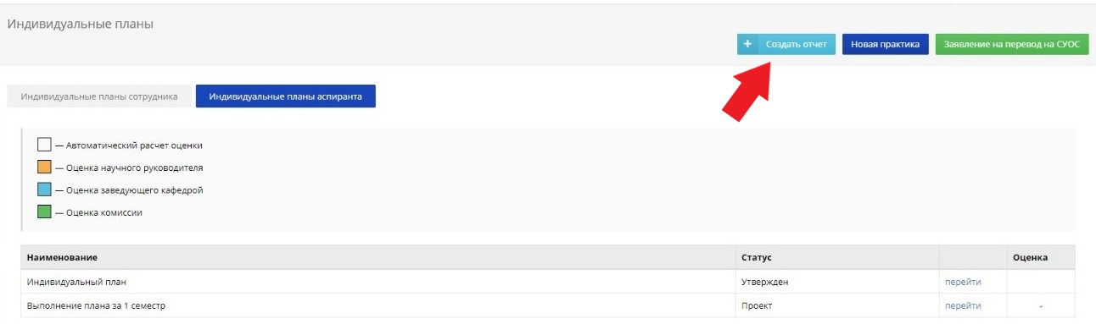

10) Always fill out all the information about your research activities in the ISU. Reports must be filled out every semester for successful passing the faculty (winter) and inter-faculty (summer) session. The information should reflect data on scientific work and publications.
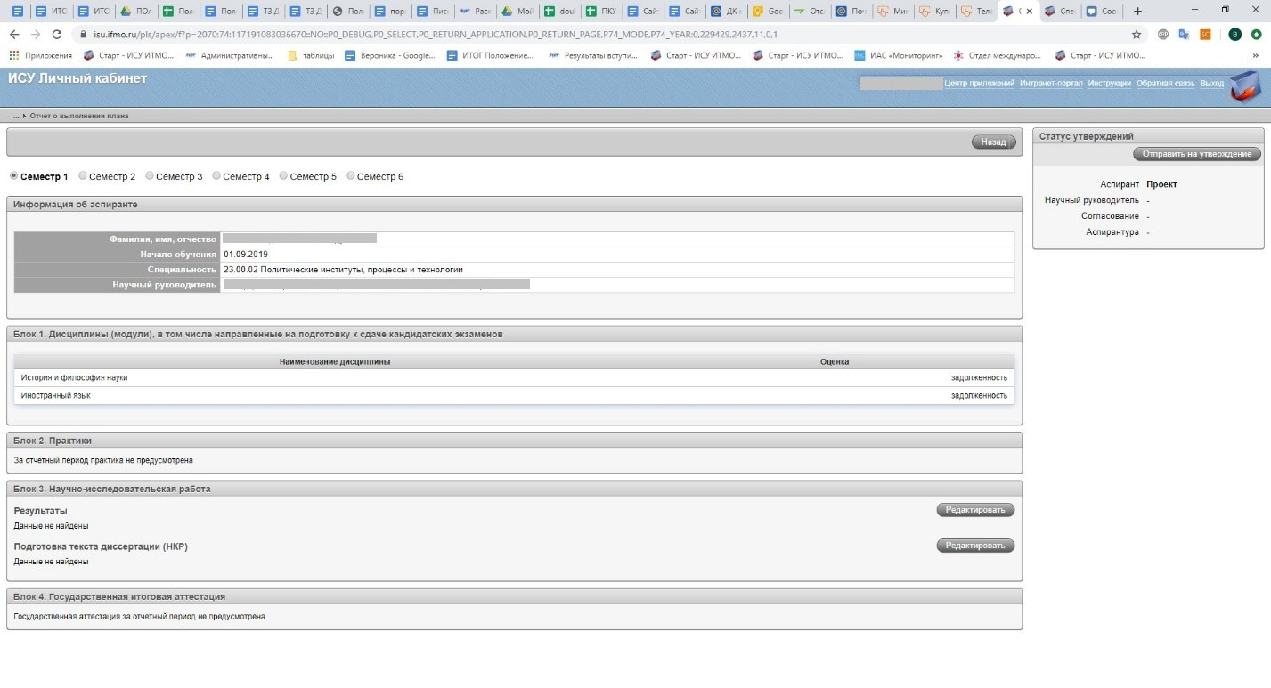
11) Dear postgraduate students!
Please note that all your individual achievements: publications, participation in conferences, grants and other results must be entered into the ISU system. This is necessary for the successful passing the faculty, inter-faculty session and subsequent dissertation.
To fill out this information, you need to enter your personal ISU page and select the results and achievements section (Результаты и достижения), and then add the relevant achievements (Добавить результаты).
