Уважаемые коллеги,
10 октября 2014 в 14:00
на кафедре фотоники и оптоинформатики НИУ ИТМО в международном институте “Фотоника и Оптоинформатика” в ауд. 104 (1 этаж, холл кафедры) состоится лекция в рамках
курса “Нанофотоника” на тему:
“Transformation Optics”
Prof. Ulf Leonhardt
Weizmann Institute of Science
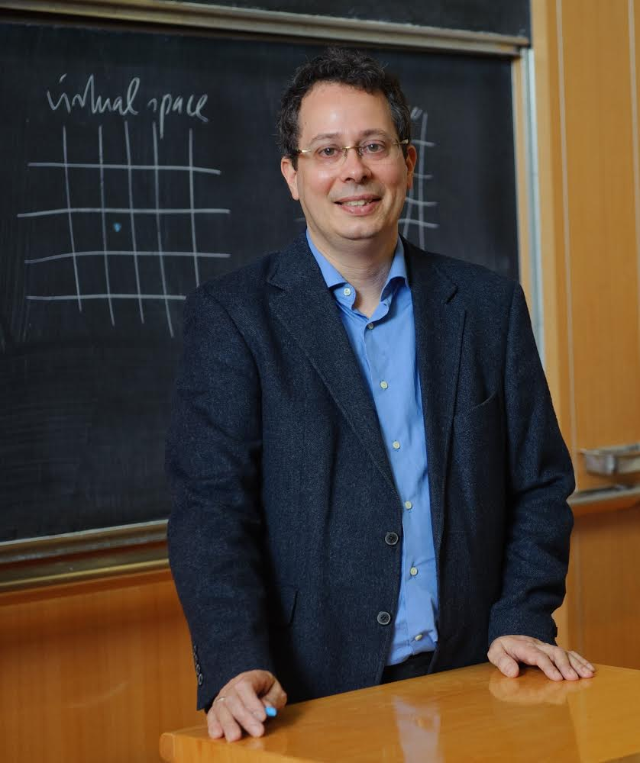
- Transformation optics grew out of ideas for invisibility cloaking devices and exploits connections between electromagnetism in media and in geometries. Within a short time it grew into a lively research area with applications ranging from invisibility and perfect imaging to the quantum physics of black holes.
- Invisibility has been a subject of fiction for millennia, from myths of the ancient Greeks and Germans to modern novels and films. In 2006 invisibility turned from fiction into science, primarily initiated by the publication of first ideas for cloaking devices and the subsequent demonstration of cloaking for microwaves.

- Perfect imaging is the ability to optically transfer images with a resolution not limited by the wave nature of light. Advances in imaging are of significant importance to modern electronics, because the structures of microchips are made by photolithography; in order to make smaller structures, light with increasingly smaller wavelength is used, which is increasingly difficult.

- Black holes are surrounded by horizons that create quantum particles from the virtual particles of the quantum vacuum, Hawking radiation. Understanding and testing this mysterious phenomenon will shed light on connections between quantum physics and general relativity.
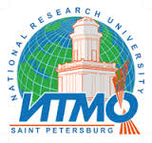
Контактная информация:
Ходзицкий Михаил Константинович
Адрес: Кадетская линия д.3 Б
Тел: +7 931 261 63 92

